Part A — Design- Canonical event-driven commerce platform enabling independent billing and fulfillment migration to Azure with full auditability and replay

Commerce Transaction Platform (Monolith to Azure Migration)

Reference Architecture Diagram
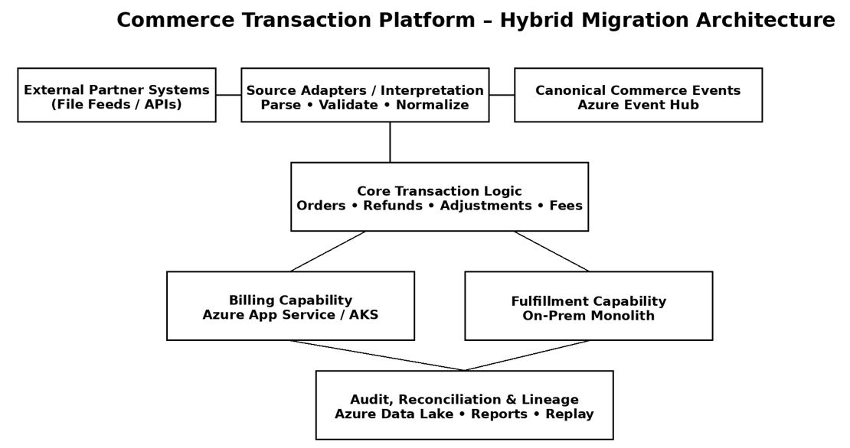
Figure 1 Reference Architecture
External Partner Sources → Source Adapters → Canonical Commerce Events → Core Transaction Logic → Hybrid Capability Migration → Audit & Reconciliation

Written Explanation
Platform Approach
This design treats the commerce system as a platform, not a set of point-to-point integrations. Architecture isolates partner variability at the edges while keeping transaction semantics stable at the core, enabling correctness, auditability, and incremental modernization.

Separation of Source Interpretation from Core Logic
Each external partner is handled through a source-specific adapter responsible for parsing files, validating structure, and interpreting partner-specific semantics. Adapters contain no billing or fulfillment logic and may evolve independently as partner schemas change.
Interpreted data is converted into a canonical commerce event model that represents stable business intent (orders, order items, refunds, fees, and adjustments). All downstream processing operates exclusively on this canonical representation, ensuring that partner-specific differences never leak into core transaction logic.

Canonical Representation
The canonical model serves as a contract between ingestion and transaction processing. It decouples business meaning from file formats, supports versioning, and enables replay, correction, and audit. Canonical events are immutable and enriched with full lineage metadata (source, file identifier, row identifier, timestamps), allowing deterministic reprocessing and reconciliation.

Azure Event Hub vs Event Grid
The authoritative transaction stream is implemented using Azure Event Hub. Event Hub is selected because the platform requires durable, high-throughput, ordered event streams with consumer-controlled replay to support billing correctness, reconciliation, and hybrid operation during migration.
Azure Event Grid is intentionally not used as the system of record for transactions. Event Grid is better suited for reactive notifications and orchestration (e.g., signaling batch completion or triggering downstream workflows) and may complement Event Hub, but it does not provide the replay and durability guarantees required for financial transaction processing.

Auditability and Reconciliation
Auditability is achieved through immutable canonical events, raw source retention, and deterministic transformations. Reconciliation is supported by replayable ingestion pipelines, explicit correction events, and comparison of source totals to canonical aggregates. This ensures operational confidence and regulatory readiness without manual intervention.

Monolith-to-Azure Migration (Billing First)
To migrate billing to Azure while fulfillment remains on-prem, the monolith is refactored to introduce explicit capability boundaries. Shared in-process calls are replaced with event-driven or service-level interfaces so billing no longer depends on monolithic state.
Fulfillment continues on-prem and publishes canonical events. Azure-based billing consumes the same events and evolves independently. Given intermittent connectivity, the system favors availability over strict consistency: fulfillment proceeds locally, and billing processes events asynchronously when connectivity resumes. Idempotent consumers prevent duplication.
Progressive cutover is achieved via dual publishing, shadow billing runs, and feature flags. Rollback is performed by disabling Azure consumers without impacting fulfillment, limiting blast radius and avoiding regressions.

Summary
By stabilizing the core around canonical events and absorbing change at the edges, this design enables rapid partner onboarding, safe hybrid migration, and long-term platform evolution without sacrificing correctness or auditability.

Part B — Order Normalization
This project normalizes heterogeneous order files from multiple external commerce systems into a canonical, item-level event format.
System A provides one row per order item, while System B embeds multiple SKUs within a single order row.
Source-specific adapters transform each input into a unified “OrderItemCreated” event model.
The solution is CLI-driven to mirror real-world batch ingestion pipelines.
Run: “./run.sh line_item_orders.csv packed_orders.csv”
- Extract all the files attached in the email to a folder similar to shown below. 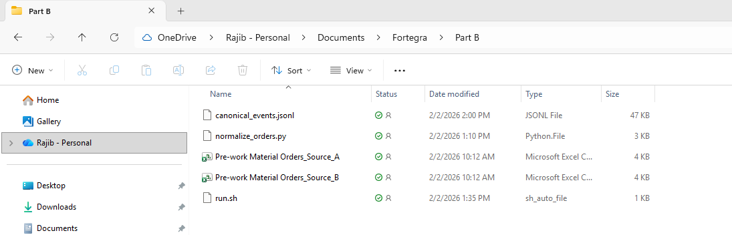
- chmod +x run.sh…as per the compress file attached in the email after extracting to a folder that is open in VSCode in Windows with python library installed.
- In VSCode open the folder Terminal Menu Select Bash Run “chmod +x run.sh”
- Run “./run.sh "Pre-work Material Orders_Source_A.csv" "Pre-work Material Orders_Source_B.csv"
- You should see the following output as I have tested.
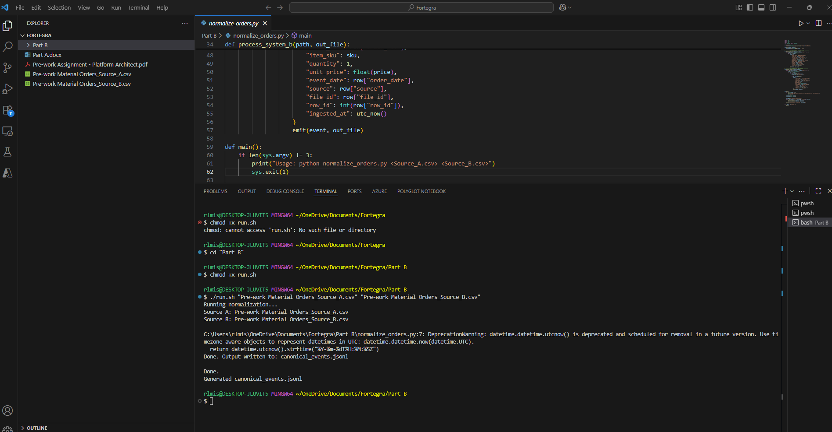

Clarifying questions – Risk Reduction
The solution demonstrates how heterogeneous partner inputs can be normalized into a stable canonical event model, enabling Fortegra to scale onboarding while retaining governance, auditability, and decision authority.
Source & Data Semantics
  - Are SKUs unique per partner, per program, or globally?
  - Can a single order contain mixed product semantics?
  - How should retired or renamed SKUs be handled?
Volume & Latency
  - Expected peak order and item throughput per source?
  - Batch vs near-real-time expectations?
  - Replay windows and retention requirements?
Governance & Compliance
  - Regulatory retention and audit requirements?
  - Source-level SLAs and data quality expectations?
  - How are disputes and corrections handled?
Platform Evolution
  - Expected cadence of new partner onboarding?
  - Schema evolution tolerance (backward/forward compatibility)?
  - AI advisory vs decision authority boundaries?

